Dokumentasi project Schedulerdb :

Repository : <http://128.21.31.46:8888/JAVA/schedulerdb.git>

Yang diperhatikan saat run project (sebelum melakukan fungsi apaapun) :

* Ketika run project pertama kali, maka tabel – tabel didatabase akan dicreate sendiri di MySQL
* Ketika database sudah tercreate, maka isi data di tabel notification_configuration dengan query sebagai berikut :

*INSERT INTO `notifications_configuration` (`NC_ID`,`NC_PLATFORM`,`NC_HOST`,`NC_PORT`,`NC_USERNAME`,`NC_PASSWORD`,`NC_AUTH`,`NC_SENDER`,`NC_RECEIVER`,`NC_SUBJECT`,`NC_CONTENT`) VALUES (1,1,'smtp.gmail.com','587','schedulerdb@gmail.com','schedulerdb123456',1,'schedulerdb@gmail.com','itweb@sinarmasmsiglife.co.id','{Process} Scheduler {JobName} !','{Process} Scheduler {JobName} in {GroupName}');*

**Tampilan** :

Halaman Awal :

Url : <http://localhost:9090/schedulerdb/>

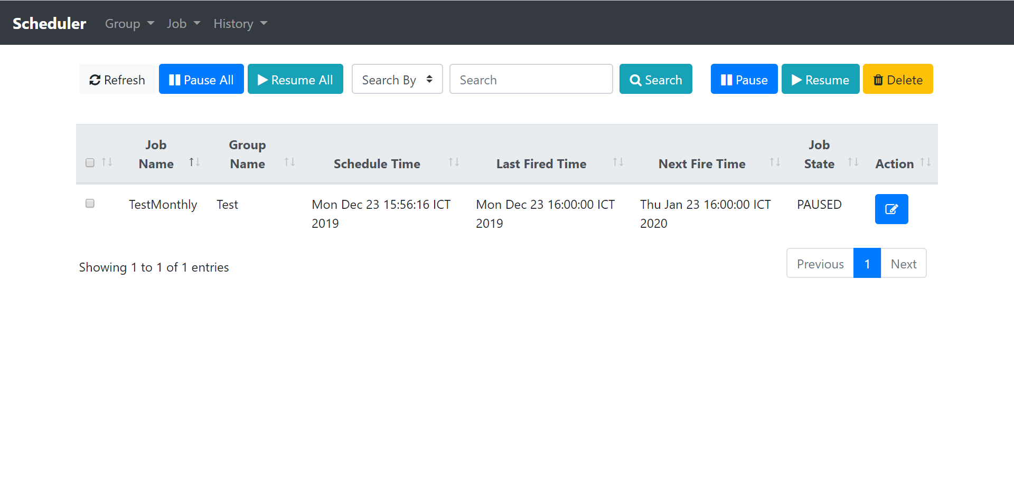

Halaman Job Group :

Url : <http://localhost:9090/schedulerdb/group>

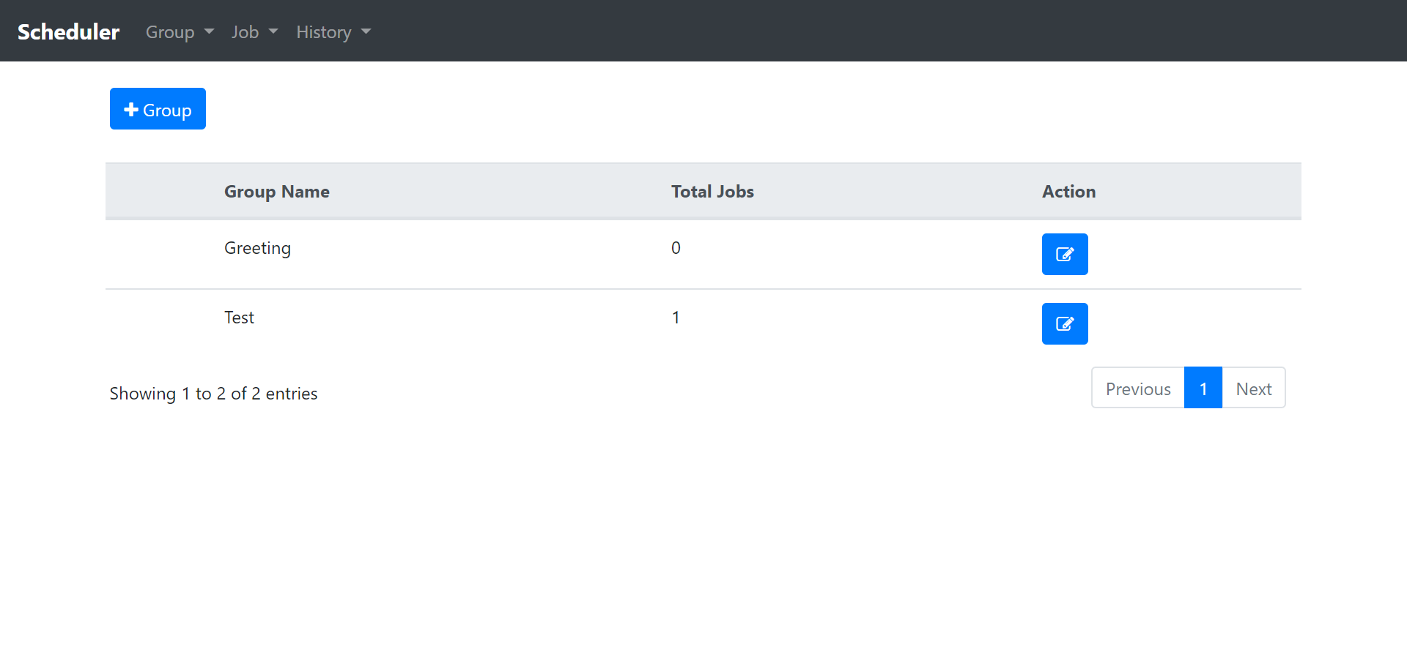

Halaman Job :

Url : <http://localhost:9090/schedulerdb/job>

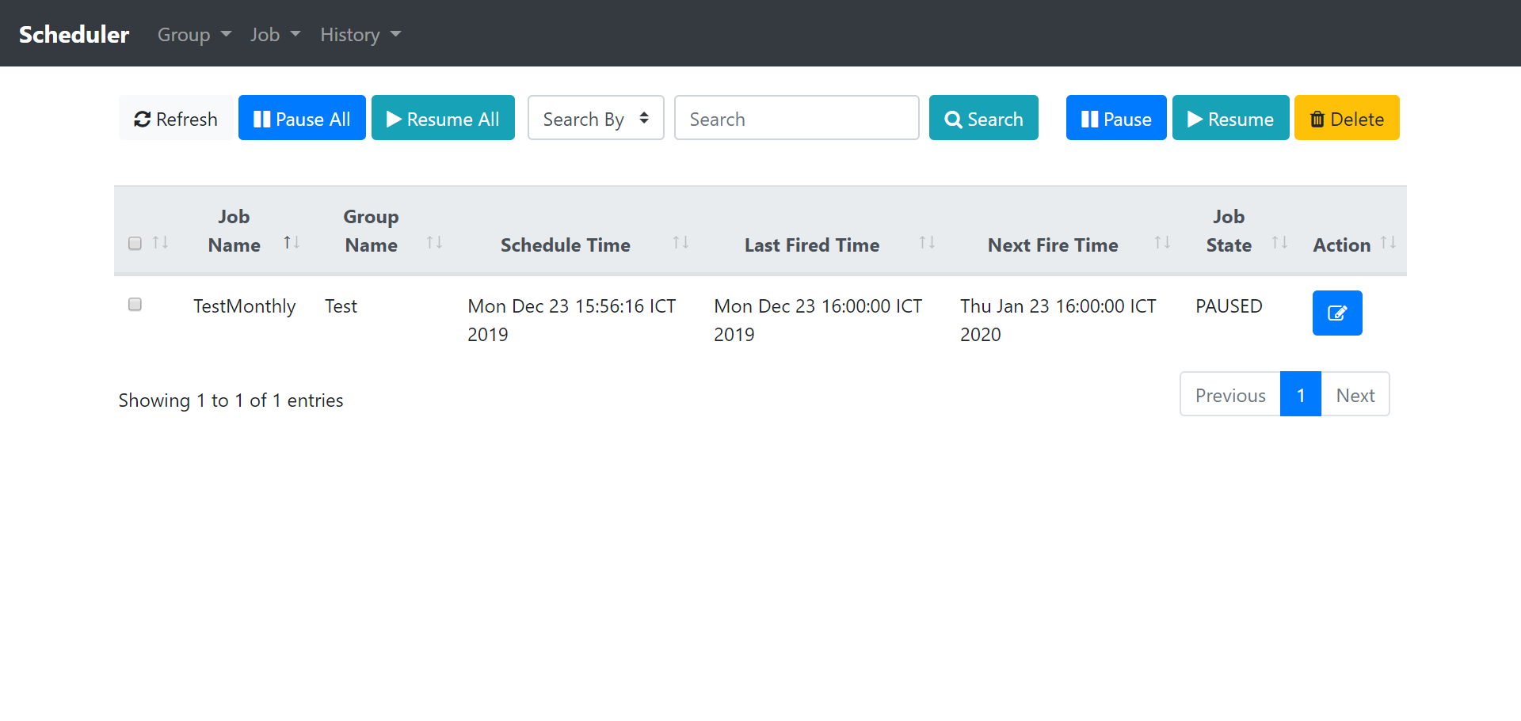

Url : <http://localhost:9090/schedulerdb/job/create?jobName=&groupName=>

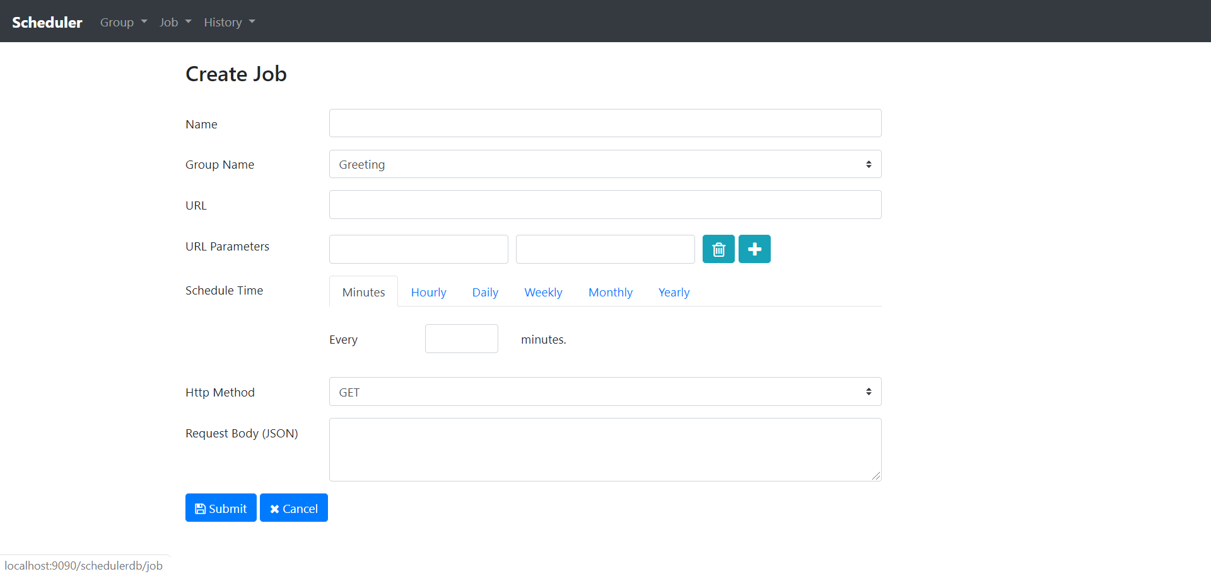

Url : <http://localhost:9090/schedulerdb/job/create?jobName=TestMonthly&groupName=Test>

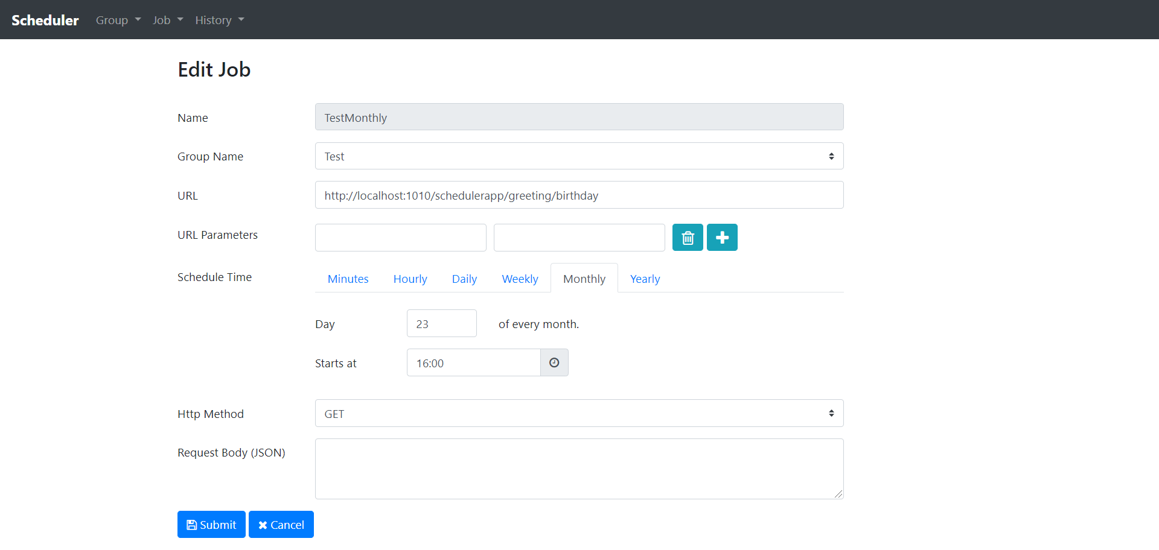

Url : <http://localhost:9090/schedulerdb/history>

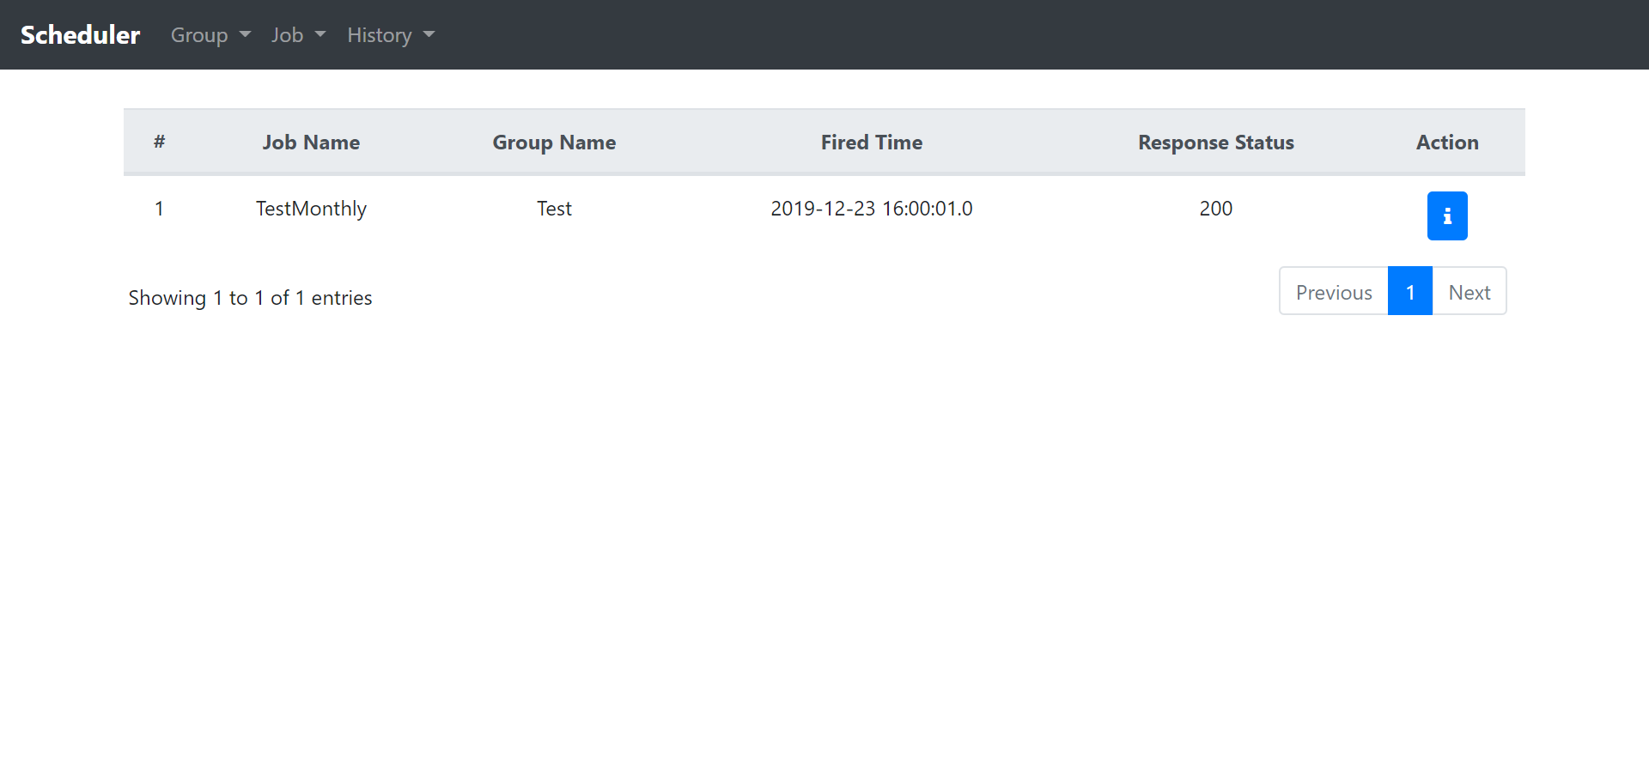

Url : <http://localhost:9090/schedulerdb/history/1>

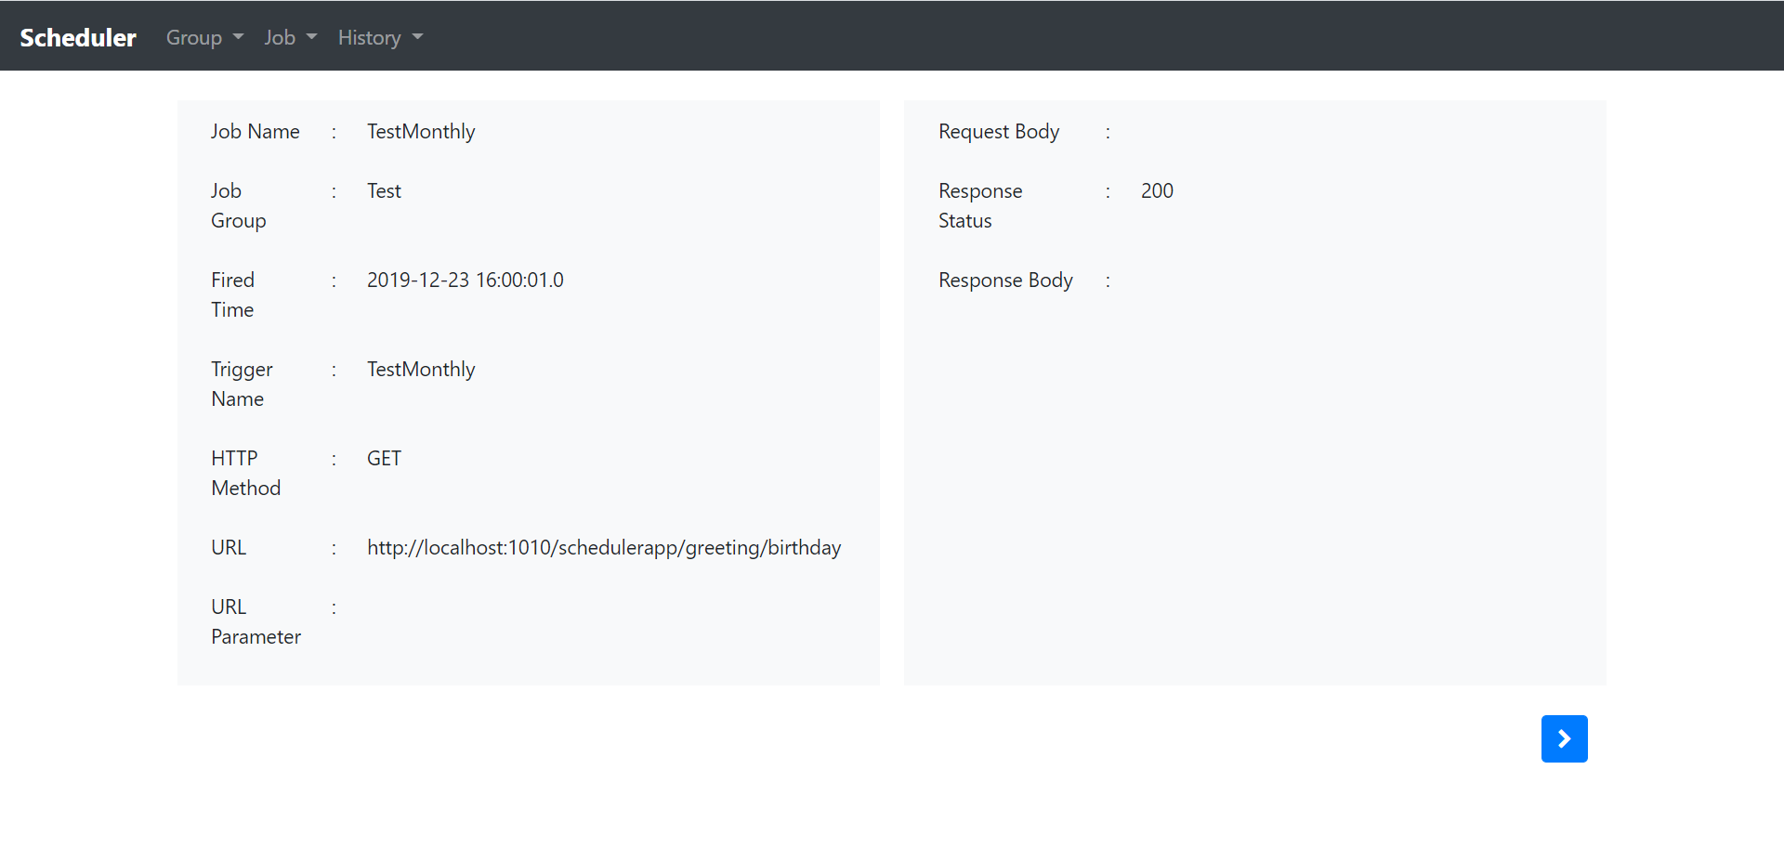

**Edit server port** di application.properties

